Entry Registration Number:

16D

You may leave this blank if you are submitting your Project Details File online as electronic copy.

1. Title of the Invention

SentiBots- smart, centimeter-sized swarmbots

2. What stage is the invention at?

❒ Concept  Design Prototype  Production  Sales being made

3. Brief Description of the Invention

Briefly describe your invention
Give a brief description of your invention: What is the invention for? What is it made of? How does it work? Etc.

Introduction
Current UAV systems available in the defense science industry mostly involve single UAV systems in which a single robot is used to carry out operations like surveillance. This results in the problem where a single robot or drone has to carry multiple sensors and work on multiple tasks one by one in an operation. These UAV systems are therefore mostly considered inefficient and they take prolonged periods of time to carry out operations due to their lack of ability to multitask.

Another problem is that in current UAV systems due to there being a remote controller/pilot there is a range constraint imposed on the drone itself by the transmission device. Furthermore, the requirement of a remote pilot creates the possible of human error which would not be present in autonomous systems.

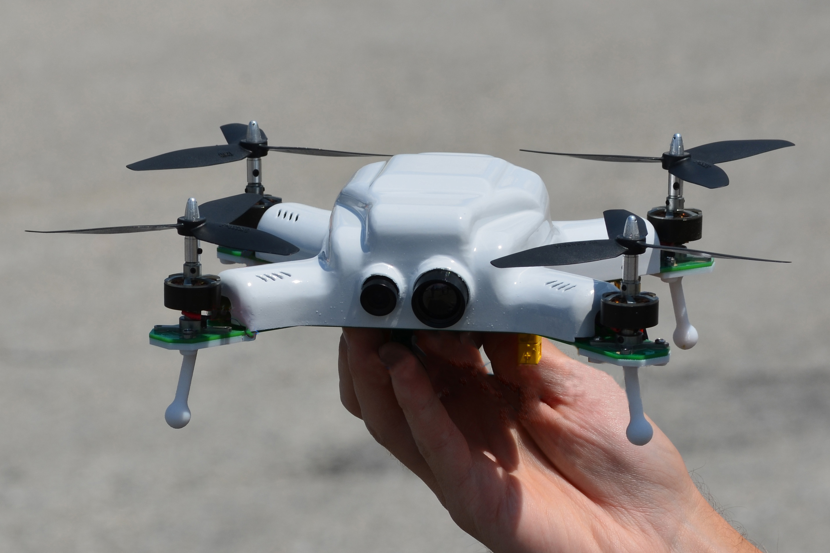
Figure 1- Conventional UAV

Our solution
Our solution is the implementation of a swarm platform for search and rescue and surveillance operations in the military. Our swarm platform has several benefits which include the ability to multitask and to operate in an autonomous fashion. SentiBot is a hardware and software optimized platform for swarm algorithms. By using the intelligent algorithms detailed in later parts of this report, we are able to use our SentiBots to enhance the range and multitasking abilities of Singapore’s drones.

Our swarm system also has benefits in that each SentiBot is highly customizable and modular allowing it to be fitted with a multitude of sensors which are appropriate for that mission. This coupled with the swarm system allows us to build various combinations of swarms consisting of SentiBots each equipped with a slight different set of tools. That allows the SentiBot to go through any terrain possible and also accomplish all different varieties of missions. This is detailed further in the following sections.

Hardware-optimization
Our SentiBot is hardware optimized in 2 different aspects- electronics and frame-design. Looking at the electronics in the SentiBot you will realize that the brains of the SentiBot is the Intel Edison processor which provides 500 MHz of processing speed. It also provides 512MB of RAM and 4GB internal storage. This allows the Edison to carry out high speed calculations on board and do complicated tasks like vision tracking and 3D mapping. The electronics also includes an Electronic Ducted Fan unit (EDF) for thrust and 4 ultra-micro servos all powered off an 11.1V 1300mAh battery. This along with a nominal draw current of 7A during a hover provides us with an approximate 10-15min of flight time. To accommodate the Intel Edison we also designed and fabricated a custom PCB which has all the breakouts required for this platform.
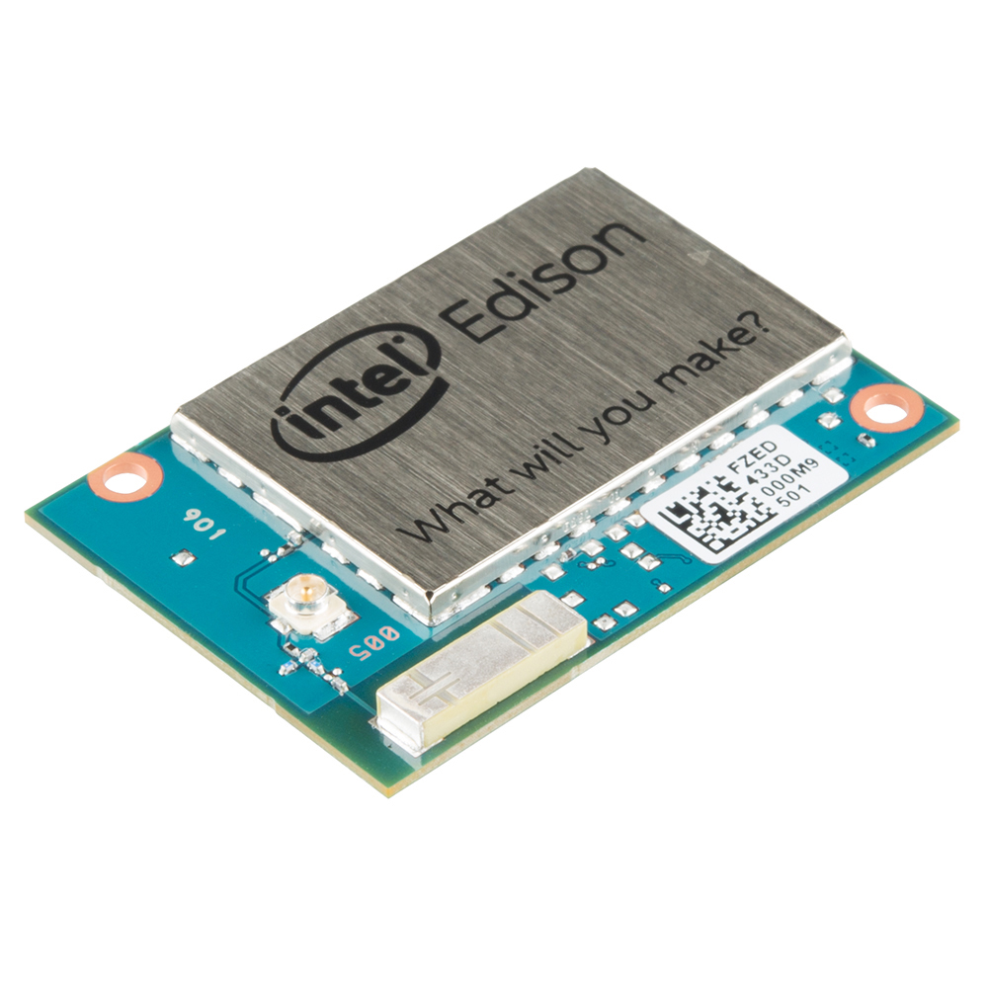
Figure 2- Intel Edison board

All these electronics are cramped into an extremely functional and unconventional frame design. Conventional quadrotor type frame designs are not optimized for swarm platforms as they have many dangerous high speed moving parts which can be damaged in the case of a mid-air collision. Our frame design encloses all the moving parts in a sturdy 3D printed frame, making it a very resilient platform for environments like search and rescue. The concept of this unconventional frame design is that the air being blown out of the bottom of the drone can be directed to one side or another by the 4 control surfaces allowing the drone to move around. Working in the same principle as an airplane made to stand up, this design takes the versatility and vertical take-off and landing (VTOL) capabilities from the quadrotor and combines it with the resilience and simplicity of an aircraft.

The SentiBot is also extremely modular consisting of 2 halves that are joined together by 3 joining pieces. The top half contains all the power electronics- the electronics that drive the system. The bottom half on the other hand contains all the intelligence of the system including the processors and sensors. This allows for easy modifications to be made to the system and quick repairs to be done as getting to the internals is as easy as removing 3 bolts.

Software-optimization
The making of a good drone is not only defined by the quality and versatility of its hardware but also by the integration of its software. Our SentiBot’s control system is managed by the ATMEGA 328 chip onboard the custom PCB. The ATMEGA chip reads from the onboard inertial measurement unit (IMU) and uses it to control a PID loop which stabilizes the SentiBot in flight. In manual control mode, commands are sent via the SSH protocol to the Intel Edison board which then transmits the information to the ATMEGA 328 chip via the UART connection.

In autonomous mode, the SentiBot uses the onboard monocular camera to carry out monocular simultaneous location and mapping algorithm (SLAM) using a robot operating system (ROS) library. This allows the SentiBot to carry out 3D mapping and also know the position of itself relative to the surroundings.

As a swarm, there are many optimizations that can be made to improve the system as a whole. I have listed 2 such optimizations below. The first optimization is that as a swarm the computing power can be pooled and each SentiBot could be a node in a swarm wide supercomputer. This could enhance the overall performance of the SentiBots. By using a mesh network like architecture we could also enhance the range of the SentiBot as user commands can be relayed through the mesh network consisting of SentiBots.

Conclusion
The SentiBot system is a highly capable platform and has several applications in the defense science industry. The multitasking abilities of the SentiBot coupled with the ability to have a failsafe if one of your drones fail, the swarm system is perfect for defense science applications. The durable hardware allows for it to survive even in the harshest environments and the software optimizes the performance further.

Explain the relevance of the invention to defence and security

There is a high relevance of this invention to defense and security. The main application of this is in the search and rescue industry. Search and rescue requires robots to carry out search and rescue jobs which are too dangerous for humans to carry out themselves. Most search and rescue operations are carried out in an unknown environment with many physical hazards like unstable ground and other dangers. The search area for these operations are usually relatively large. The autonomous mapping capabilities of the SentiBot platform allow it to be the perfect candidate to operate in an unknown environment without any human operator. The swarm capabilities allow it to cover a large area is a shorter period of time with multitasking to co-operatively search the area.

Another industry the SentiBot could be useful in the surveillance sector. Covert operations usually require low profile robots for surveillance operations. Currently, the use of land rovers is being tested in several military applications. The swarm and autonomous navigation abilities of the platform along with the low profile and small design allows for the SentiBot platform to be a capable machine for this job. The durability of the SentiBot also allows it to operate in all terrains and the ability to fly gives it an edge over the land rovers.

Photograph(s) or drawing(s) of your invention prototype
Please supply at least one photograph or drawing of your invention prototype. Show the internal structure of your invention by illustration, if necessary
(*Actual invention/prototype is required for presentation during the interview if your invention is short-listed)

4. Detailed explanation of the Invention

Describe the novelty or originality of your invention
List the outstanding characteristics of your invention

The SentiBot is very novel given that not much research, if any, has been done into building a swarm optimized drone with these specific advantages. The design offers modularity that is definitely not available in off the shelf drones or flight platforms as of now. Furthermore, the fully enclosed design makes it very durable and rugged for use in defense science applications. Hardware-wise, optimization to allow the swarm to interact without the fear of mid-air collisions is unprecedented in previous research and inventions.

The system is also novel in its software where technologies like mesh networking and pooled computing have been exploited to the benefit of the system providing even more optimization for swarm.

These features are simply not available right now due to the lack of swarm system implementation in defense science. My design can change all of that and provide a modular and durable platform optimized for swarm development, for use in the defense science industry.

Are there existing or alternative products?
What sets your invention apart from previous creations, in terms of its feature, its method or its functionality?

As of now there are no similar products available as this area is still being researched on.

One flight platform that is being researched on that has a similar frame design to this is the Spherical Flight vehicle being researched into by the Japanese Ministry of defense.

However, although this flight platform shares a similar design it does not share the same goals as this flight platform is not intended to be swarm optimized and does not have the swarm benefits outlined previously.

Other points or aspects that you would like to highlight, if any.

5. Practical Applications and Usefulness of the Invention

Who would the user be?
The users of this platform would be the surveillance sector and the search and rescue sector. It could also be potentially useful in the security sector where these robots could be used as an alternative to CCTV cameras.

Why would potential users want to use your invention?
The advantages of using a swarm system as outlined above provide a greater efficiency where carrying out tasks in this field by eliminating human error.

It could also help in hazardous situations where humans cannot be deployed to help and act as an alternative to conventional rovers which are limited by their range of motion, modularity and ability to handle various terrains.

As a security system, the SentiBot could be a replacement for CCTV cameras as a SentiBot is mobile and that offers an advantage which CCTV cameras do not. It also can help pursuit an invader as a security system to provide eyes on the invader at all times.

6. Additional Information about the Invention

Have you got any patent right for your invention?
If yes, please provide the name of Principal inventor and number of inventors listed in your patent document.

No

Did you receive assistance in the development of this invention?
If yes, please describe the nature & extent of assistance received.

We were given financial help from the school to fund the project and professional advice from Prof Prahlad Vadekkepat who is a professor at NUS. He helped us clear our doubts with control system theory and aided us with the algorithms.

Has your invention been submitted to any other competition or won any award?
If yes, please provide details.

No

Write a short description of your experience as an inventor
We found the experience extremely educational as we enjoyed the prospect of talking real life problems instead of virtual ones presented to us in school. The ability to think out of the box and do critical problem solving was a very important aspect of the project as well. All in all, the experience did us well in showing us that we need to have the ability to solve problems to be an effective innovator.

7. Endorsement by Proper Authority
(*applicable to those applying through schools, institutes or companies, etc.)

This submission has been endorsed by:

Name:

Designation:

Organization:

Address:

Contact No.:

Appendix

8. Other supporting materials (*Optional)

Trials, papers, literature or correspondence, which might assist the judges in evaluating your idea
(*insert a new page if space is not sufficient)

